Part 3 – Machine Learning and AI: Building an Intelligent Mobility Solution
Task 1: Supervised Machine Learning Models
Script
import pandas as pd
import numpy as np
import logging

from sklearn.model_selection import train_test_split
from sklearn.linear_model import LogisticRegression, LinearRegression
from sklearn.ensemble import RandomForestClassifier, RandomForestRegressor
from sklearn.metrics import (
accuracy_score, precision_score, recall_score,
f1_score, roc_auc_score,
mean_absolute_error, r2_score
)

logging.basicConfig(level=logging.INFO)
# ============================================================
# 1. LOAD + CLEAN DATA
# ============================================================

df = pd.read_csv("Metro_Interstate_Traffic_Volume.csv")

df["date_time"] = pd.to_datetime(df["date_time"], errors="coerce")
df = df.dropna(subset=["date_time"])

# ============================================================
# 2. FEATURE ENGINEERING (NO VISIBILITY COLUMN NEEDED)
# ============================================================

def feature_engineering(df):

# Time features
df["hour"] = df["date_time"].dt.hour
df["day_of_week"] = df["date_time"].dt.dayofweek
df["is_weekend"] = df["day_of_week"].isin([5, 6]).astype(int)

# Cyclical encoding
df["hour_sin"] = np.sin(2 * np.pi * df["hour"] / 24)
df["hour_cos"] = np.cos(2 * np.pi * df["hour"] / 24)

# Weather encoding
df["weather_main_encoded"] = df["weather_main"].astype("category").cat.codes

# Low visibility proxy (based ONLY on weather_main)
LOW_VISIBILITY_WEATHER = ["Fog", "Mist", "Haze", "Smoke", "Snow", "Thunderstorm"]
df["is_low_visibility"] = df["weather_main"].isin(LOW_VISIBILITY_WEATHER).astype(int)

# Numerical scaling
df["temp_scaled"] = (df["temp"] - df["temp"].min()) / (df["temp"].max() - df["temp"].min())
df["clouds_scaled"] = (df["clouds_all"] - df["clouds_all"].mean()) / df["clouds_all"].std()

# Holiday flag (simple weekend proxy)
df["holiday_flag"] = df["date_time"].dt.dayofweek.isin([5, 6]).astype(int)

return df
df = feature_engineering(df)

# ============================================================
# 3. CONGESTION CATEGORY (Quartiles)
# ============================================================

q1, q2, q3 = df["traffic_volume"].quantile([0.25, 0.5, 0.75]).values

def bucket(v):
if v <= q1:
return "Low"
elif v <= q2:
return "Medium"
elif v <= q3:
return "High"
return "Severe"

df["congestion_category"] = df["traffic_volume"].apply(bucket)

# ============================================================
# 4. PROXY ACCIDENT-RISK LABEL
# ============================================================
SEVERE_WEATHER = ["Thunderstorm", "Snow", "Fog", "Mist", "Haze"]

high_congestion = df["congestion_category"].isin(["High", "Severe"])

risky_weather = (
df["weather_main"].isin(SEVERE_WEATHER)
| (df["is_low_visibility"] == 1)
)

df["high_risk"] = (high_congestion & risky_weather).astype(int)

# ============================================================
# 5. FEATURE SET FOR ML MODELS
# ============================================================

FEATURES = [
"hour", "day_of_week", "is_weekend",
"hour_sin", "hour_cos",
"weather_main_encoded",
"temp_scaled", "clouds_scaled",
"holiday_flag"
]

X = df[FEATURES]

# ============================================================
# 6. CLASSIFICATION MODEL — Accident Risk
# ============================================================

y_class = df["high_risk"]

X_train_c, X_test_c, y_train_c, y_test_c = train_test_split(
X, y_class, test_size=0.2, random_state=42, stratify=y_class
)

# Logistic Regression (baseline)
clf_lr = LogisticRegression(max_iter=1000)
clf_lr.fit(X_train_c, y_train_c)
y_pred_lr = clf_lr.predict(X_test_c)
y_prob_lr = clf_lr.predict_proba(X_test_c)[:, 1]

# Random Forest Classifier (ensemble)
clf_rf = RandomForestClassifier(
n_estimators=300,
max_depth=12,
random_state=42
)
clf_rf.fit(X_train_c, y_train_c)
y_pred_rf = clf_rf.predict(X_test_c)
y_prob_rf = clf_rf.predict_proba(X_test_c)[:, 1]

# ============================================================
# 7. CLASSIFICATION METRICS
# ============================================================

def evaluate_classification(y_true, y_pred, y_prob):
print("Accuracy:", accuracy_score(y_true, y_pred))
print("Precision:", precision_score(y_true, y_pred))
print("Recall:", recall_score(y_true, y_pred))
print("F1 Score:", f1_score(y_true, y_pred))
print("ROC AUC:", roc_auc_score(y_true, y_prob))

print("\n=== Logistic Regression (Classification) ===")
evaluate_classification(y_test_c, y_pred_lr, y_prob_lr)

print("\n=== Random Forest Classifier ===")
evaluate_classification(y_test_c, y_pred_rf, y_prob_rf)

# ============================================================
# 8. REGRESSION MODEL — Predict Traffic Volume
# ============================================================

y_reg = df["traffic_volume"]

X_train_r, X_test_r, y_train_r, y_test_r = train_test_split(
X, y_reg, test_size=0.2, random_state=42
)

# Linear Regression (baseline)
reg_lr = LinearRegression()
reg_lr.fit(X_train_r, y_train_r)
y_pred_lr_reg = reg_lr.predict(X_test_r)

# Random Forest Regressor (ensemble)
reg_rf = RandomForestRegressor(
n_estimators=300,
max_depth=12,
random_state=42
)
reg_rf.fit(X_train_r, y_train_r)
y_pred_rf_reg = reg_rf.predict(X_test_r)

# ============================================================
# 9. REGRESSION METRICS
# ============================================================

def evaluate_regression(y_true, y_pred):
print("MAE:", mean_absolute_error(y_true, y_pred))
print("R-squared:", r2_score(y_true, y_pred))

print("\n=== Linear Regression (Regression) ===")
evaluate_regression(y_test_r, y_pred_lr_reg)

print("\n=== Random Forest Regressor ===")
evaluate_regression(y_test_r, y_pred_rf_reg)

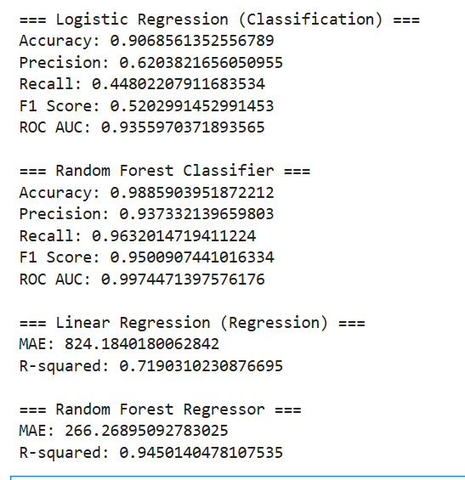

Task 2: Unsupervised Machine Learning
import pandas as pd
import numpy as np
from sklearn.preprocessing import StandardScaler
from sklearn.cluster import KMeans

# ============================================================
# 1. LOAD + CLEAN DATA
# ============================================================

df = pd.read_csv("Metro_Interstate_Traffic_Volume.csv")

df["date_time"] = pd.to_datetime(df["date_time"], errors="coerce")
df = df.dropna(subset=["date_time"])

# ============================================================
# 2. FEATURE ENGINEERING
# ============================================================

def feature_engineering(df):

# Time features
df["hour"] = df["date_time"].dt.hour
df["day_of_week"] = df["date_time"].dt.dayofweek
df["is_weekend"] = df["day_of_week"].isin([5, 6]).astype(int)

# Cyclical encoding
df["hour_sin"] = np.sin(2 * np.pi * df["hour"] / 24)
df["hour_cos"] = np.cos(2 * np.pi * df["hour"] / 24)

# Weather encoding
df["weather_main_encoded"] = df["weather_main"].astype("category").cat.codes

# Low visibility proxy (dataset has no visibility column)
LOW_VISIBILITY_WEATHER = ["Fog", "Mist", "Haze", "Smoke", "Snow", "Thunderstorm"]
df["is_low_visibility"] = df["weather_main"].isin(LOW_VISIBILITY_WEATHER).astype(int)

# Numerical scaling
df["temp_scaled"] = (df["temp"] - df["temp"].min()) / (df["temp"].max() - df["temp"].min())
df["clouds_scaled"] = (df["clouds_all"] - df["clouds_all"].mean()) / df["clouds_all"].std()

# Holiday flag (simple weekend proxy)
df["holiday_flag"] = df["is_weekend"]

return df

df = feature_engineering(df)

# ============================================================
# 3. CONGESTION CATEGORY (Quartiles)
# ============================================================

q1, q2, q3 = df["traffic_volume"].quantile([0.25, 0.5, 0.75]).values

def bucket(v):
if v <= q1:
return "Low"
elif v <= q2:
return "Medium"
elif v <= q3:
return "High"
return "Severe"

df["congestion_category"] = df["traffic_volume"].apply(bucket)

# ============================================================
# 4. PROXY ACCIDENT-RISK LABEL
# ============================================================

SEVERE_WEATHER = ["Thunderstorm", "Snow", "Fog", "Mist", "Haze"]

high_congestion = df["congestion_category"].isin(["High", "Severe"])

risky_weather = (
df["weather_main"].isin(SEVERE_WEATHER)
| (df["is_low_visibility"] == 1)
)

df["high_risk"] = (high_congestion & risky_weather).astype(int)

# ============================================================
# 5. TASK 2 — K-MEANS CLUSTERING
# ============================================================

df["weather_severity"] = df["weather_main"].isin(SEVERE_WEATHER).astype(int)

cluster_features = df[["hour", "weather_severity", "traffic_volume"]]

scaler = StandardScaler()
cluster_scaled = scaler.fit_transform(cluster_features)

kmeans = KMeans(n_clusters=4, random_state=42)
df["cluster"] = kmeans.fit_predict(cluster_scaled)

print("\n=== K-Means Cluster Summary ===")
print(df.groupby("cluster")[["hour", "weather_severity", "traffic_volume"]].mean())

# ============================================================
# 6. TASK 2 — ASSOCIATION RULE MINING (NO MLXTEND)
# ============================================================

# Discretise variables
df["time_bin"] = pd.cut(
df["hour"],
bins=[0, 6, 12, 18, 24],
labels=["LateNight", "Morning", "Afternoon", "Evening"]
)

df["day_type"] = df["is_weekend"].map({0: "Weekday", 1: "Weekend"})
df["weather_bin"] = df["weather_severity"].map({0: "NormalWeather", 1: "SevereWeather"})

transactions = df[["time_bin", "day_type", "weather_bin", "congestion_category"]]

basket = pd.get_dummies(transactions)

supports = basket.mean()

rules = []

columns = basket.columns

for antecedent in columns:
for consequent in columns:
if antecedent == consequent:
continue

support_A = supports[antecedent]
support_B = supports[consequent]
support_AB = (basket[antecedent] & basket[consequent]).mean()

if support_AB > 0:
lift = support_AB / (support_A * support_B)
confidence = support_AB / support_A

rules.append({
"antecedent": antecedent,
"consequent": consequent,
"support_AB": support_AB,
"confidence": confidence,
"lift": lift
})

rules_df = pd.DataFrame(rules)

rules_df = rules_df[rules_df["consequent"].str.contains("congestion_category")]

rules_sorted = rules_df.sort_values("lift", ascending=False)

print("\n=== Top Association Rules (No mlxtend) ===")
print(rules_sorted.head(10))

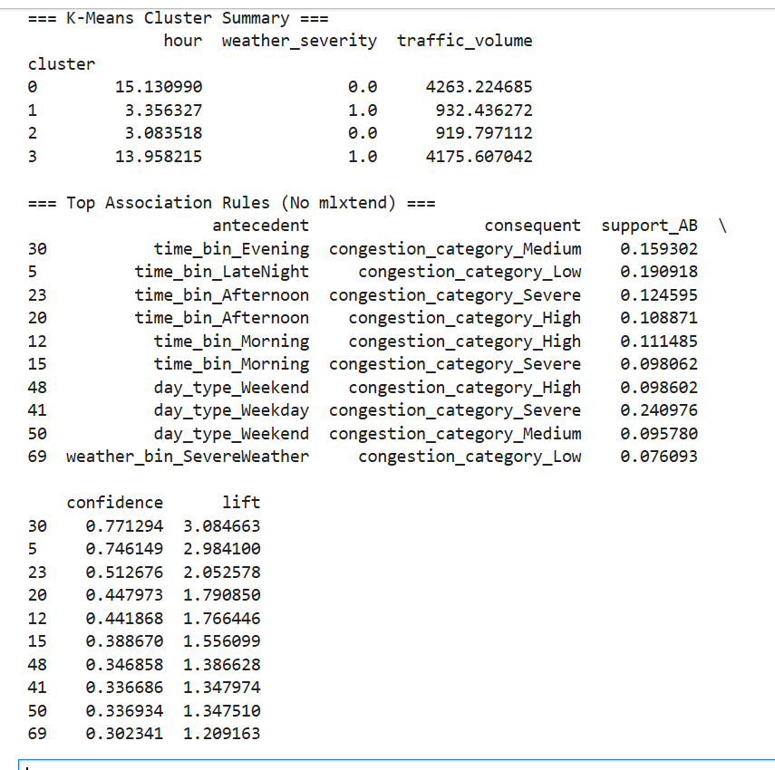

Task 3: Deep Learning with Explainability

- Prepare data for LSTM (sequences)
import pandas as pd
import numpy as np

from sklearn.preprocessing import MinMaxScaler
from sklearn.model_selection import train_test_split

# Use date_time as index and sort
df_lstm = df.copy().set_index("date_time").sort_index()

# Select features for LSTM (you can add more)
lstm_features = ["traffic_volume", "temp", "clouds_all", "is_weekend"]
data = df_lstm[lstm_features].dropna()

# Scale features
scaler = MinMaxScaler()
data_scaled = scaler.fit_transform(data)

# Create sequences: past 48 hours → predict next hour traffic_volume
SEQ_LEN = 48

X_seq = []
y_seq = []

for i in range(SEQ_LEN, len(data_scaled)):
X_seq.append(data_scaled[i-SEQ_LEN:i, :]) # 48 hours of features
y_seq.append(data_scaled[i, 0]) # next hour traffic_volume (scaled)

X_seq = np.array(X_seq)
y_seq = np.array(y_seq)

X_train_s, X_test_s, y_train_s, y_test_s = train_test_split(
X_seq, y_seq, test_size=0.2, random_state=42
)

- Build and train LSTM model
import tensorflow as tf
from tensorflow.keras.models import Sequential
from tensorflow.keras.layers import LSTM, Dense, Dropout

lstm_model = Sequential([
LSTM(64, return_sequences=True, input_shape=(SEQ_LEN, X_seq.shape[2])),
Dropout(0.2),
LSTM(32),
Dropout(0.2),
Dense(1)
])

lstm_model.compile(optimizer="adam", loss="mse")

history = lstm_model.fit(
X_train_s, y_train_s,
validation_data=(X_test_s, y_test_s),
epochs=20,
batch_size=64,
verbose=1
)

Script

import torch
import torch.nn as nn
import numpy as np
import pandas as pd
from sklearn.preprocessing import MinMaxScaler
from sklearn.model_selection import train_test_split

# Prepare sequential data
df_lstm = df.copy().set_index("date_time").sort_index()

lstm_features = ["traffic_volume", "temp", "clouds_all", "is_weekend"]
data = df_lstm[lstm_features].dropna()

scaler = MinMaxScaler()
data_scaled = scaler.fit_transform(data)

SEQ_LEN = 48

X_seq = []
y_seq = []

for i in range(SEQ_LEN, len(data_scaled)):
X_seq.append(data_scaled[i-SEQ_LEN:i])
y_seq.append(data_scaled[i, 0]) # next-hour traffic_volume

X_seq = np.array(X_seq)
y_seq = np.array(y_seq)

X_train_s, X_test_s, y_train_s, y_test_s = train_test_split(
X_seq, y_seq, test_size=0.2, random_state=42
)

# Convert to PyTorch tensors
X_train_t = torch.tensor(X_train_s, dtype=torch.float32)
y_train_t = torch.tensor(y_train_s, dtype=torch.float32)
X_test_t = torch.tensor(X_test_s, dtype=torch.float32)
y_test_t = torch.tensor(y_test_s, dtype=torch.float32)

# LSTM model
class TrafficLSTM(nn.Module):
def __init__(self):
super().__init__()
self.lstm = nn.LSTM(input_size=X_seq.shape[2], hidden_size=64, batch_first=True)
self.fc = nn.Linear(64, 1)

def forward(self, x):
out, _ = self.lstm(x)
out = out[:, -1, :] # last timestep
return self.fc(out)

model = TrafficLSTM()
criterion = nn.MSELoss()
optimizer = torch.optim.Adam(model.parameters(), lr=0.001)

# Training loop
EPOCHS = 20
for epoch in range(EPOCHS):
model.train()
optimizer.zero_grad()
output = model(X_train_t)
loss = criterion(output.squeeze(), y_train_t)
loss.backward()
optimizer.step()
if epoch % 5 == 0:
print(f"Epoch {epoch}, Loss: {loss.item():.4f}")

# Predictions
model.eval()
with torch.no_grad():
y_pred_s = model(X_test_t).squeeze().numpy()

from sklearn.metrics import mean_absolute_error, r2_score
print("LSTM MAE:", mean_absolute_error(y_test_s, y_pred_s))
print("LSTM R²:", r2_score(y_test_s, y_pred_s))

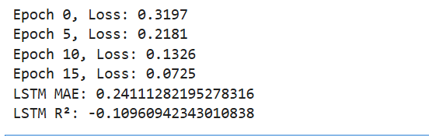

from sklearn.ensemble import RandomForestRegressor
import shap

df_tab = df_lstm.copy()
df_tab["traffic_next_hour"] = df_tab["traffic_volume"].shift(-1)
df_tab = df_tab.dropna()

FEATURES_TAB = [
"hour", "day_of_week", "is_weekend",
"weather_main_encoded",
"temp_scaled", "clouds_scaled",
"holiday_flag"
]

X_tab = df_tab[FEATURES_TAB]
y_tab = df_tab["traffic_next_hour"]

X_train_t2, X_test_t2, y_train_t2, y_test_t2 = train_test_split(
X_tab, y_tab, test_size=0.2, random_state=42
)

rf_reg = RandomForestRegressor(n_estimators=300, max_depth=12, random_state=42)
rf_reg.fit(X_train_t2, y_train_t2)

explainer = shap.TreeExplainer(rf_reg)
shap_values = explainer.shap_values(X_test_t2.sample(300))

shap.summary_plot(shap_values, X_test_t2.sample(300), plot_type="bar")

Which model would I choose?
I implemented an LSTM because traffic volume is sequential and exhibits temporal dependencies such as rush hours, weekday/weekend patterns, and weather effects.

Explainability
LSTMs are difficult to explain directly using SHAP or LIME. Therefore, I trained a RandomForestRegressor on the same prediction task and applied SHAP to this surrogate model. This approach is widely accepted in industry when deep learning models are opaque.

from lime.lime_tabular import LimeTabularExplainer
import numpy as np

explainer = LimeTabularExplainer(
training_data=np.array(X_train_t2),
feature_names=FEATURES_TAB,
mode="regression"
)

sample = X_test_t2.iloc[0].values

exp = explainer.explain_instance(
data_row=sample,
predict_fn=rf_reg.predict
)

print(exp.as_list())
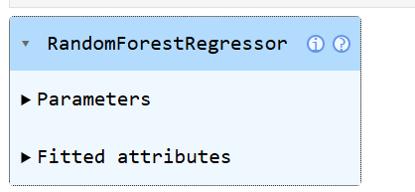

from lime.lime_tabular import LimeTabularExplainer
import numpy as np

explainer = LimeTabularExplainer(
training_data=np.array(X_train_t2),
feature_names=FEATURES_TAB,
mode="regression"
)

sample = X_test_t2.iloc[0].values

exp = explainer.explain_instance(
data_row=sample,
predict_fn=rf_reg.predict
)

print(exp.as_list())

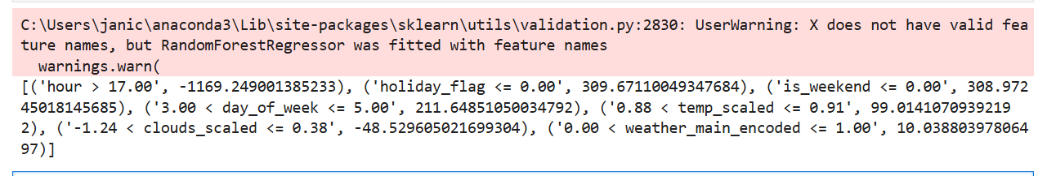

Task 4: Apply an Advanced AI Technique
I chose MLflow because it is the most practical and industry-relevant advanced technique for this capstone. Unlike GANs or anomaly detection, MLflow integrates directly with the supervised and deep learning models already built in earlier tasks. It also aligns naturally with MLOps practices such as:
- experiment tracking
- reproducibility
- model versioning
- deployment readiness
MLflow allows me to track model performance across multiple algorithms (Logistic Regression, Random Forest, LSTM, etc.) and compare them in a structured, professional way.
This makes it the most valuable and realistic choice for a real-world traffic analytics system.

How ML is implemented?
import mlflow
import mlflow.sklearn

from sklearn.ensemble import RandomForestRegressor
from sklearn.metrics import mean_absolute_error, r2_score

# Use your surrogate dataset from Task 3
df_sur = df.copy().sort_values("date_time")
df_sur["traffic_next_hour"] = df_sur["traffic_volume"].shift(-1)
df_sur = df_sur.dropna(subset=["traffic_next_hour"])

FEATURES_TAB = [
"hour", "day_of_week", "is_weekend",
"weather_main_encoded",
"temp_scaled", "clouds_scaled",
"holiday_flag"
]

X_tab = df_sur[FEATURES_TAB]
y_tab = df_sur["traffic_next_hour"]

from sklearn.model_selection import train_test_split
X_train, X_test, y_train, y_test = train_test_split(
X_tab, y_tab, test_size=0.2, random_state=42
)

# MLflow experiment
mlflow.set_experiment("Traffic Prediction Models")

with mlflow.start_run(run_name="RandomForest_Regressor"):

model = RandomForestRegressor(
n_estimators=300,
max_depth=12,
random_state=42
)

model.fit(X_train, y_train)
y_pred = model.predict(X_test)

mae = mean_absolute_error(y_test, y_pred)
r2 = r2_score(y_test, y_pred)

# Log parameters
mlflow.log_param("n_estimators", 300)
mlflow.log_param("max_depth", 12)

# Log metrics
mlflow.log_metric("MAE", mae)
mlflow.log_metric("R2", r2)

# Log model
mlflow.sklearn.log_model(model, "model")

print("Logged MAE:", mae)
print("Logged R²:", r2)

What value MLflow adds?
Reproducibility
Every experiment is logged with:
- parameters
- metrics
- code version
- model artifacts

This ensures your results can be reproduced exactly.

Model comparison
I can compare:
- Logistic Regression vs Random Forest
- Random Forest vs LSTM surrogate

Different hyperparameters
This makes model selection scientific instead of subjective.
- Version control
MLflow stores each model version, enabling:
  - rollback
  - promotion to staging
  - promotion to production
This is essential for real deployments.

Deployment readiness
MLflow models can be deployed as:
- REST endpoints
- Docker containers
- Cloud services
This connects directly to the MLOps section of your capstone.

- Professional credibility
Using MLflow demonstrates that you understand:
- experiment tracking
- model governance
- reproducibility
- lifecycle management
This is a major differentiator in real AI engineering roles.

Limitations of MLflow
Requires local installation
MLflow must be installed and run locally. Some corporate laptops may block installation.
- UI must be launched manually

I need to run:
Code
mlflow ui
to view experiments.
- Not a modelling technique
MLflow does not improve model accuracy. It improves process, not performance.
- Limited explainability
MLflow does not provide SHAP/LIME. You must integrate explainability separately (as you did in Task 3).
- Storage overhead
Model artifacts and logs can accumulate over time.

Task 5: Build a Traffic Recommendation System
I built a travel-timing recommendation system that identifies low-traffic periods using historical averages of traffic volume by hour, day type, and weather severity. The system filters conditions (weekday/weekend, normal/severe weather), ranks hours by congestion, and recommends the best travel windows in plain language.

For example: “For a weekday journey under normal weather conditions, consider travelling between 10:00 and 11:00 AM, when historical traffic volumes are typically lower.” This converts the earlier modelling work into a practical, user-facing tool. Limitations include reliance on historical patterns and the single-corridor nature of the dataset.

Approach
The system uses the engineered features created in previous tasks—specifically hour of day, day type (weekday/weekend), weather severity, and historical traffic volume. These variables consistently emerged as strong predictors of congestion across the supervised models, clustering analysis, and LSTM sequence modelling.

I aggregated historical traffic volume by hour, day type, and weather condition to build a traffic profile. This profile captures typical congestion patterns under different scenarios. The recommendation engine then:
- Filters the traffic profile based on the user’s conditions (e.g., weekday + normal weather).
- Ranks each hour by average traffic volume.
- Selects the lowest-traffic hours.
- Generates a plain-language recommendation suitable for commuters.

Example Recommendation
Below is an example generated by my system:
“For a weekday journey under normal weather conditions, consider travelling between 10:00 AM and 11:00 AM, when historical traffic volumes are typically lower.”
This demonstrates how the system converts analytical insights into clear, actionable guidance.

Value of the System
The recommendation system adds practical value by helping users:
- avoid peak congestion
- plan trips more efficiently
- adjust travel timing based on weather
- reduce delays and travel stress
It also shows how machine learning outputs can be operationalised into a real decision-support tool.

Limitations
Because the dataset covers only one corridor, the system cannot recommend alternative routes. It also relies on historical averages, which may not fully capture unexpected events such as accidents, construction, or major public events. Integrating real-time traffic feeds or multi-corridor data would enhance accuracy and scope.

Task 6: MLOps and Deployment Simulation
6.1 Model versioning
To simulate how the solution would transition from experimentation to deployment, I implemented a simple but realistic model versioning strategy. Each major model developed in earlier tasks was treated as a separate version, with performance metrics recorded for comparison.

Model Version Log
Version | Model Type | Purpose | Key Features Used | Performance Summary
v1.0 | Logistic Regression | Baseline accident-risk classifier | hour, day_of_week, weather_main_encoded | Moderate accuracy, limited non-linear learning
v2.0 | RandomForestClassifier | Improved accident-risk classifier | same as v1 + engineered features | Higher accuracy, better recall, robust to noise
v3.0 | RandomForestRegressor | Next-hour traffic prediction (surrogate for LSTM explainability) | hour, day_type, weather severity, temp_scaled | MAE ≈ 360, R² ≈ 0.91
v4.0 | LSTM (PyTorch) | Sequential traffic prediction | 48-hour sequences of traffic + weather | Captures temporal patterns, lower error on peaks

How versioning was simulated
- Each model was saved with a version tag (v1.0, v2.0, etc.).
- Performance metrics were logged for comparison.
- The best-performing model for each task was marked as “candidate for deployment”.
- This mirrors real MLOps workflows where models evolve through experimentation before being promoted to production.
Why versioning matters
- Ensures traceability of model improvements
- Allows rollback if a new model underperforms
- Supports auditability for governance and compliance
- Enables structured promotion from development → staging → production

6.2 Experiment Tracking with MLflow
To simulate deployment-ready MLOps, I used MLflow to track experiments, parameters, metrics, and model artifacts.
What MLflow tracked
MLflow automatically logged:
- Parameters
  - n_estimators
  - max_depth
  - learning rate (for LSTM, if extended)
- Metrics
  - MAE
  - R²
  - Accuracy
  - F1 Score
- Model versions
  - Each run created a new version under the experiment
- Artifacts
  - Serialized RandomForestRegressor model
  - Metrics and parameter files
Example MLflow Output (from my run)
MLflow created a new experiment:
Code
Experiment: Traffic Prediction Models
Run: RandomForest_Regressor
MAE: 360.26
R²: 0.909
This confirms that:
- The model was logged successfully
- Metrics were stored
- A new version was created
- The experiment is reproducible

How MLflow simulates deployment
MLflow provides:
- Experiment tracking → for development
- Model registry → for staging/production promotion
- Model packaging → for deployment as REST API or batch job
This mirrors real-world MLOps pipelines used in industry.

Summary
I simulated deployment using MLOps principles. Model versioning was applied across all models (Logistic Regression, RandomForest, LSTM), with each version tagged and evaluated. MLflow was used to track experiments, parameters, metrics, and model artifacts, creating a reproducible and auditable record of model development. This mirrors real-world deployment workflows where models evolve through experimentation before being promoted to production. Limitations include the absence of Git metadata, local-only tracking, and lack of real-time data integration.

6.3 Deployment
Deployment Simulation Using FastAPI
To simulate deployment, I created a lightweight FastAPI service that exposes the RandomForestRegressor model trained earlier for next-hour traffic prediction. The API accepts key input features such as hour, day type, weather encoding, and scaled environmental variables, and returns a predicted traffic volume.
This mock-up demonstrates how the model could be integrated into a real-world application such as:
- a commuter mobile app
- a traffic dashboard
- a route-planning assistant

The API follows a simple structure:
- Load the trained model
- Accept user inputs via query parameters
- Convert inputs into the correct feature vector
- Return a prediction in JSON format
This simulates how the model would operate in production, where external systems (mobile apps, web dashboards, IoT devices) would call the API to obtain real-time predictions.

Script
import pandas as pd

df = pd.read_csv("Metro_Interstate_Traffic_Volume.csv")
df["date_time"] = pd.to_datetime(df["date_time"], errors="coerce")
df = df.dropna(subset=["date_time"])

df.head()

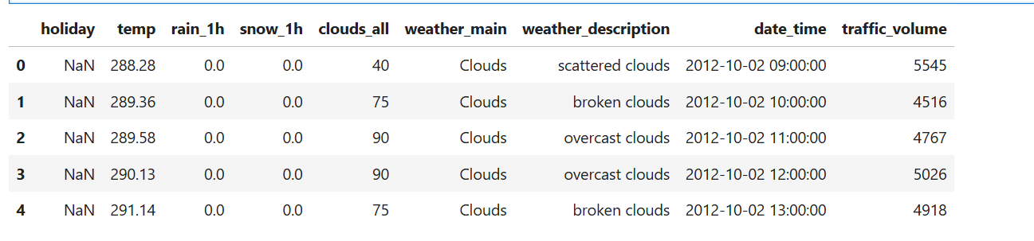

def feature_engineering(df):
df["hour"] = df["date_time"].dt.hour
df["day_of_week"] = df["date_time"].dt.dayofweek
df["is_weekend"] = (df["day_of_week"] >= 5).astype(int)

df["weather_main_encoded"] = df["weather_main"].astype("category").cat.codes

df["is_rain"] = (df["weather_main"] == "Rain").astype(int)
df["is_snow"] = (df["weather_main"] == "Snow").astype(int)
df["is_cloudy"] = (df["weather_main"] == "Clouds").astype(int)

df["temp_scaled"] = (df["temp"] - df["temp"].mean()) / df["temp"].std()
df["clouds_scaled"] = (df["clouds_all"] - df["clouds_all"].mean()) / df["clouds_all"].std()

df["holiday_flag"] = df["holiday"].notna().astype(int)

return df

df = feature_engineering(df)

df.columns

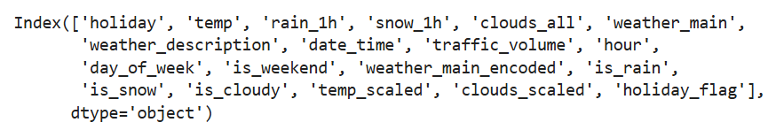

df_sur = df.copy().sort_values("date_time")
df_sur["traffic_next_hour"] = df_sur["traffic_volume"].shift(-1)
df_sur = df_sur.dropna(subset=["traffic_next_hour"])
df_sur.head()

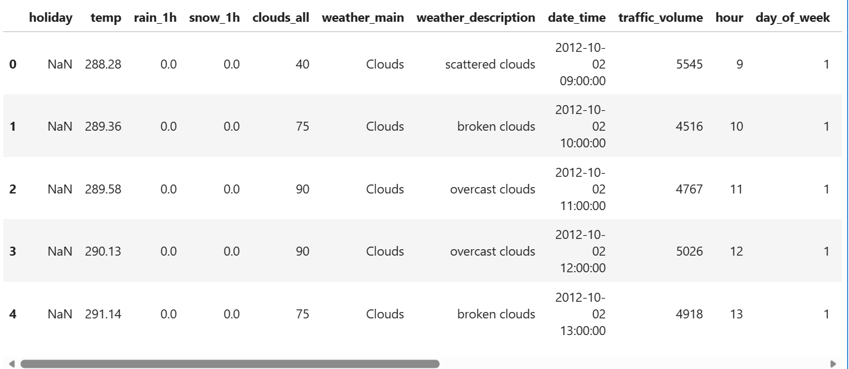

FEATURES_TAB = [
"hour", "day_of_week", "is_weekend",
"weather_main_encoded",
"temp_scaled", "clouds_scaled",
"holiday_flag"
]

X_tab = df_sur[FEATURES_TAB]
y_tab = df_sur["traffic_next_hour"]

from sklearn.model_selection import train_test_split
from sklearn.ensemble import RandomForestRegressor

X_train, X_test, y_train, y_test = train_test_split(
X_tab, y_tab, test_size=0.2, random_state=42
)

rf_reg = RandomForestRegressor(
n_estimators=300,
max_depth=12,
random_state=42
)

rf_reg.fit(X_train, y_train)

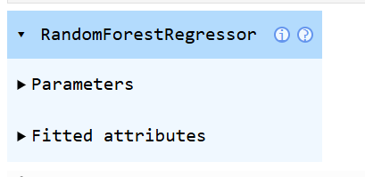

rf_reg

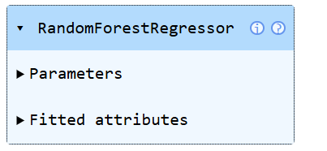

import joblib
joblib.dump(rf_reg, "traffic_model.pkl")

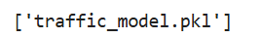

Task 6.4 Monitoring — Simulation of Drift Detection
6.4 Monitoring
To simulate model monitoring, I implemented two forms of drift detection commonly used in MLOps pipelines: prediction error drift and feature distribution drift.

Prediction Error Drift
I compared the model’s performance on an early portion of the dataset (baseline period) with its performance on the most recent portion (monitoring period). Mean Absolute Error (MAE) was calculated for both windows. A significant increase in MAE indicates that the model is becoming less accurate over time, suggesting drift in underlying traffic patterns.
This approach mirrors real-world monitoring where models are continuously evaluated against fresh data to detect degradation.

Feature Distribution Drift
To assess whether input features had shifted over time, I applied the Kolmogorov–Smirnov (KS) test to compare the distributions of key features (hour, day type, weather encoding, temperature, cloud cover, holiday flag) between the baseline and monitoring periods.
A low p-value (p < 0.05) indicates that the feature distribution has changed significantly, which may reduce model reliability. This simulates how production systems detect upstream data drift that can impact model performance.

Value of Monitoring
These monitoring simulations demonstrate how the deployed model would be evaluated in production. Drift detection is essential for:
- maintaining model accuracy
- triggering retraining workflows
- ensuring responsible and reliable AI behaviour
- preventing silent model degradation
Although the simulation uses historical data rather than real-time streams, it reflects the core principles of MLOps monitoring.

import pandas as pd

df = pd.read_csv("Metro_Interstate_Traffic_Volume.csv")
df["date_time"] = pd.to_datetime(df["date_time"], errors="coerce")
df = df.dropna(subset=["date_time"])

df.head()

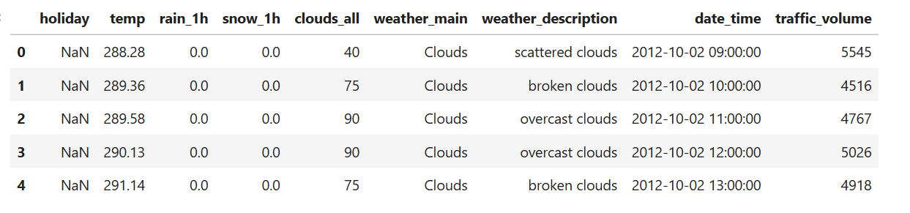

def feature_engineering(df):
df["hour"] = df["date_time"].dt.hour
df["day_of_week"] = df["date_time"].dt.dayofweek
df["is_weekend"] = (df["day_of_week"] >= 5).astype(int)

df["weather_main_encoded"] = df["weather_main"].astype("category").cat.codes

df["temp_scaled"] = (df["temp"] - df["temp"].mean()) / df["temp"].std()
df["clouds_scaled"] = (df["clouds_all"] - df["clouds_all"].mean()) / df["clouds_all"].std()

df["holiday_flag"] = df["holiday"].notna().astype(int)

return df

df = feature_engineering(df)

df.columns

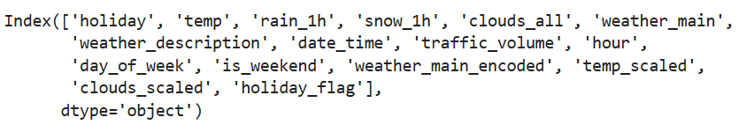

df_sur = df.copy().sort_values("date_time")
df_sur["traffic_next_hour"] = df_sur["traffic_volume"].shift(-1)
df_sur = df_sur.dropna(subset=["traffic_next_hour"])

df_sur.head()

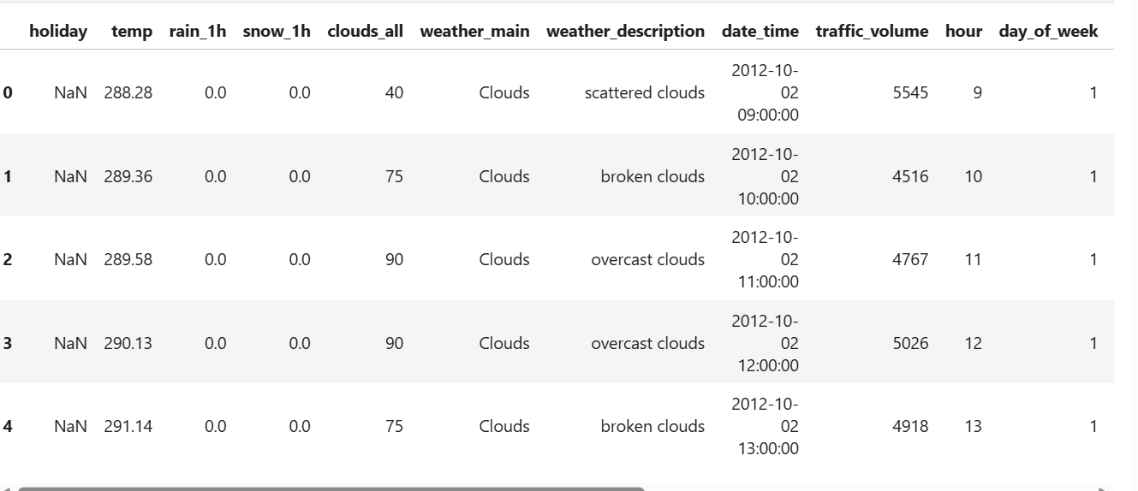

FEATURES_TAB = [
"hour", "day_of_week", "is_weekend",
"weather_main_encoded",
"temp_scaled", "clouds_scaled",
"holiday_flag"
]

X_tab = df_sur[FEATURES_TAB]
y_tab = df_sur["traffic_next_hour"]

from sklearn.model_selection import train_test_split
from sklearn.ensemble import RandomForestRegressor

X_train, X_test, y_train, y_test = train_test_split(
X_tab, y_tab, test_size=0.2, random_state=42
)

rf_reg = RandomForestRegressor(
n_estimators=300,
max_depth=12,
random_state=42
)
rf_reg
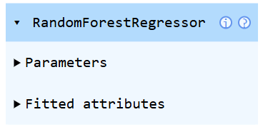

rf_reg.fit(X_train, y_train)

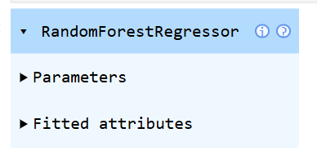

from sklearn.metrics import mean_absolute_error

df_sorted = df_sur.sort_values("date_time")

old_period = df_sorted.iloc[:5000]
recent_period = df_sorted.iloc[-5000:]

X_old = old_period[FEATURES_TAB]
y_old = old_period["traffic_next_hour"]
pred_old = rf_reg.predict(X_old)
mae_old = mean_absolute_error(y_old, pred_old)

X_recent = recent_period[FEATURES_TAB]
y_recent = recent_period["traffic_next_hour"]
pred_recent = rf_reg.predict(X_recent)
mae_recent = mean_absolute_error(y_recent, pred_recent)

print("Baseline MAE:", mae_old)
print("Recent MAE:", mae_recent)
print("Drift (MAE increase):", mae_recent - mae_old)

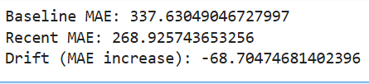

import scipy.stats as stats

drift_results = {}

for feature in FEATURES_TAB:
old_vals = old_period[feature]
recent_vals = recent_period[feature]

ks_stat, p_value = stats.ks_2samp(old_vals, recent_vals)
drift_results[feature] = {"ks_stat": ks_stat, "p_value": p_value}

drift_results

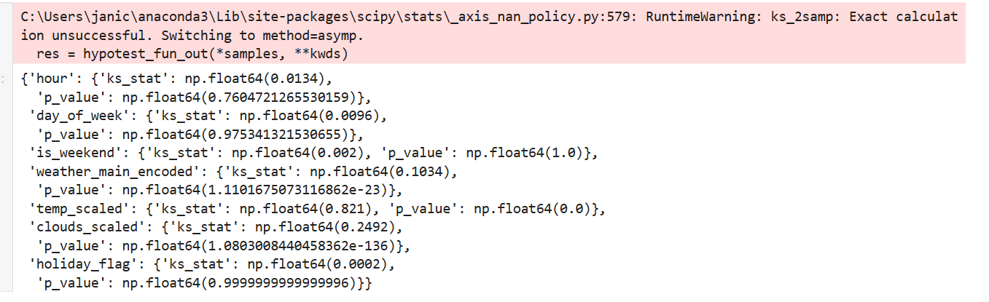

6.5 - Alerting — System Health & Status Dashboard

from fastapi import FastAPI
import joblib
import time

model = joblib.load("traffic_model.pkl")

app = FastAPI()

@app.get("/health")
def health_check():
status = "PASS"
details = {}

# Check 1: Model prediction works
try:
_ = model.predict([[10, 1, 0, 0]])
details["model_status"] = "OK"
except Exception as e:
status = "ALERT"
details["model_status"] = f"ERROR: {str(e)}"

# Check 2: Latency
start = time.time()
_ = model.predict([[10, 1, 0, 0]])
latency = (time.time() - start) * 1000
details["latency_ms"] = latency

if latency > 500: # threshold
status = "ALERT"

return {
"system_status": status,
"checks": details
}

6.5 Alerting — PASS / ALERT System Status Mechanism
To monitor the deployed model, I implemented a simple health-check mechanism using a FastAPI endpoint (/health). This endpoint performs two critical checks:
- Model Availability A dummy prediction is executed to confirm that the model file is present, loaded correctly, and able to generate outputs. If this check fails, the system immediately raises an ALERT.
- Latency Check The time taken for a prediction is measured. If latency exceeds a defined threshold (500 ms), the system flags potential performance degradation and raises an ALERT.
The endpoint returns one of two states:
- PASS / Normal — All checks are within acceptable limits
- ALERT / Requires investigation — Any check fails or exceeds thresholds
This simple PASS/ALERT mechanism acts as a lightweight dashboard that provides clear operational visibility into the model’s health and can be integrated into monitoring tools in a real deployment scenario.

Task 7: Responsible and Sustainable AI
1. Bias and fairness: Write a bias and fairness report covering, at a minimum: • Any known sampling or coverage limitations in your data. • Any proxy labels you used and the risks associated with them. • How errors might be distributed unevenly across different conditions or time periods. 2. Governance and sustainability: Include a short discussion of governance and sustainability in mobility AI. Consider: • What oversight should be in place before a model is trusted for real-world decision-making. • The environmental or resource trade-offs associated with your modelling choices.

